**Sukhjinder Kaur – 301087895 Sec.04**

V2.2

Group 4

**Jaskirat Kaur – 301107505 Sec.04**

**Amish Tangri – 301108446 Sec.04**

**Damanpreet Singh – 300895559 Sec.03**





Contents

Revision History 3

Section 1: Introduction 5

1.1 Purpose 5

1.2 Document Conventions 5

1.3 Intended Audience and Reading Suggestions 6

1.4 Project scope 6

1.5 Reference 6

Section 2: Overall Description 6

2.1 Project prospective 6

2.2 Features (Functions) 7

2.3 User Class 8

2.4 Operating Software 8

2.7 Assumptions and Dependencies 8

Section 3: External Interface Requirements 9

3.1 User Interfaces**:** 9

3.2 Hardware Interfaces: 10

3.3 Software Interfaces: 10

Stakeholder Register 11

Use Case Table 12

Section 4 13

Functional Requirements List 1 13

Use Case Formal Description 14

Swim Lane Diagram 15

Use Case Diagram 16

Section 5 17

Non-Functional Requirement List 1 17

Appendix A 17

Appendix B 17

Appendix C 18

Stakeholder Register 18

Appendix D 19

Interview Questions 19

Appendix E 20

Class Diagrams 20

Domain Class Diagram 20

CRC Cards 20

State Diagram 22

Login Process 22

Record Fitness Activity 23

Sequence Diagram 24

References 25

# Revision History

|  |  |  |  |
| --- | --- | --- | --- |
| Name | Date | Reason for Changes | Version |
| Team | Aug 14, 2020 | Logo update | 2.2 |
| Amish Tangri | Aug 13, 2020 | Technical Review | 2.1 |
| Jaskirat Kaur | Aug 13, 2020 | Added Content:  Sequence diagram | 2.1 |
| Sukhjinder Kaur | Aug 10, 2020 | Added Content:  State diagram | 2.0 |
| Damanpreet Singh | July 21, 2020 | Added Content:  Class diagram | 1.9 |
| Damanpreet Singh | July 15, 2020 | Added Content:  CRC index cards | 1.8 |
| Amish Tangri | July 15, 2020 | Added Content:  Domain class diagram | 1.8 |
| Sukhjinder Kaur | July 07, 2020 | Added Content:  Use Case Diagram | 1.7 |
| Jaskirat Kaur | July 07, 2020 | Added Content:  Use Case Description | 1.7 |
| Team | June 24, 2020 | Added Content:  Use Case Table | 1.6 |
| Team | June 19, 2020 | Added Content:  Revision History | 1.5 |
| Damanpreet Singh | June 15, 2020 | Revised Content:  2.2 | 1.4 |
| Damanpreet Singh | June 14, 2020 | Added Content:  2.2 – 2.3 – 2.4 – 2.7 | 1.3 |
| Jaskirat Kaur | June 14, 2020 | Revised Content:  1.4 – 2.1 | 1.3 |
| Jaskirat Kaur | June 13, 2020 | Added Content:  1.4 – 2.1 – 2.2 | 1.2 |
| Amish Tangri | June 13, 2020 | Revised Content:  1.1 – 1.2 – 1.3 | 1.2 |
| Amish Tangri | June 12, 2020 | Added Content:  1.1 – 1.2 – 1.3 | 1.1 |
| Sukhjinder Kaur | June 12, 2020 | Revised Content:  3.1 – 3.2 – 3.3 | 1.1 |
| Sukhjinder Kaur | June 11, 2020 | Added Content:  3.1 – 3.2 – 3.3 | 1.0 |
| Entire Group | June 11, 2020 | Name Change for App | 1.0 |

# Section 1: Introduction

### 1.1 Purpose

The main purpose of Fit-Pro is to improve the overall fitness of a user. As there are a lot of people in the world who can't take care of their health due to their busy schedules. Fit-Pro is to help people track their fitness goals. Fit-Pro is not only for the people who go to the gym but also for individuals who have health problems like diabetes, bp problems, or other problems can benefit. So basically, this app will track the diet and will also connect to the body of the user with a wearable device which will show their progress. Also, it will give them a warning if they are going off track from their diet. This app saves a lot of time and money as people who don't have time to go gyms and fitness centres can benefit with built-in home workout plans.

### 1.2 Document Conventions

|  |  |
| --- | --- |
| Acronym | Description |
| OS | Operating Software |
| SQL | Sequel Query Language |
| ATF | Automatic Testing Framework |
| PHP | Hypertext Preprocessor |
| API | Application Programming Interface |
| XML | Extensible Markup Language |
| GPS | Global Positioning System |
| FR | Functional Requirements |
| NFR | Non-Functional Requirements |

### 1.3 Intended Audience and Reading Suggestions

The app is for all the people from young to old. All groups of ages and all the genders can use it. Like youngsters can use it as they have more interest in sports so they can use it to stay fit and active. Old ones can use it as they are more vulnerable to disease so they can use it for that. The person who wants to change their lifestyle can use this app. As we now these days people don't have time to take care of their health so this will help them. This app will target the audience who wants a healthy body but don't have time for that.

### 1.4 Project scope

The rate of non-communicable diseases is increasing day by day and people should keep track of their health. Our project aim is to provide awareness among people concerning their health. Fit-Pro is our project and is a mobile and wearable application which motivates a person to set the goals that they can achieve day by day. It allows a person to take full control of their health. This app can be the most useful app which helps people to take care of their bodies and let them live a tension free life ahead. Also, a healthy mind and body will bring more focus to their tasks which would be good for society in future. Ultimately, they will enjoy their work and live a stress-free life.

### 1.5 Reference

* <https://reference.jrank.org/fitness/Fitness_Apps.html>
* <https://personal.utdallas.edu/~chung/SYSM6309/Presentations09S/RE_Submit/SRS.pdf>
* <http://www.dropitproject.com/assets/guides/DropIt_SRS.pdf>

# Section 2: Overall Description

### 2.1 Project prospective

Fit-Pro is the new software and is convenient and comfortable with all types of phones. The application comes up with the level according to your compatibility such as; Beginner, Intermediate, and Advanced, each level has different workouts. It has a 30-minute online session daily and you can also download them. It can track your progress and also motivates you with the nutrition diet. It shows the number of calories, water, vitamins and minerals that you should take in a day. Overall, this application will help you to stay fit, healthier and in shape by motivating you and providing you with information related to diet food and guiding you daily according to your goals.

### 2.2 Features (Functions)

#### Nutrition:

Whether the customer wants to lose or gain weight they will be able to use this app to track their nutrition progression and the app will help them along the way. Users can manually enter macronutrient and calorie data or for foods with a packaging, barcodes can be scanned the nutrition table in the database will automatically come up and then can be saved to the daily log sheet. Users will have option to add food under breakfast, lunch, dinner, and snacks section.

1. [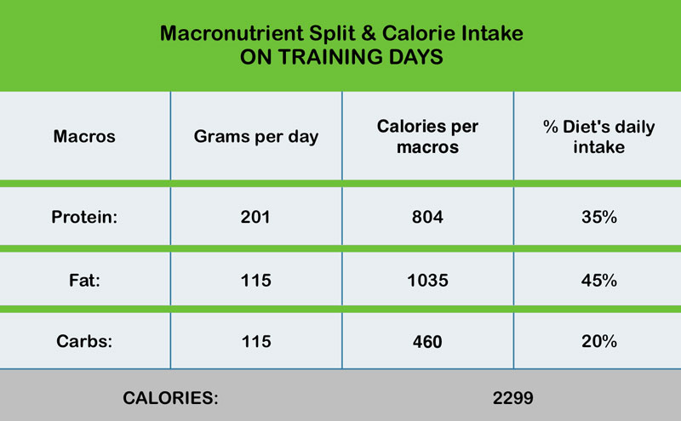](https://www.bing.com/images/search?view=detailV2&ccid=lJ2hvhIm&id=15B91A53214A8E8B092395E761C6FB355C92E4F2&thid=OIP.lJ2hvhImywkDaoVVfnPi3AHaEl&mediaurl=https%3A%2F%2Fandreaskambanis.com%2Fwp-content%2Fuploads%2F2015%2F05%2Fcalories-macros-chart.jpg&exph=495&expw=800&q=calories+and+macros+on+a+app&simid=608020145959995594&ck=9DF1B59BE35DE535D4E3A4CC8738B438&selectedindex=72&ajaxhist=0&vt=0&sim=11)Requests the input of the weight goals and a timeframe they would like to achieve.

Figure 1. Calorie and macros requirements.

1. The app will suggest certain grams of macro-nutrients depending on the calories needed in a day to achieve their end goal.
2. Food can be recorded by user to help make tracking goals easier. The premium version will record eating behaviour and suggest healthier alternatives.

#### Exercise:

There will be three types of groups of exercises strength, cardio, and other, that the customer can choose from. There will be various exercises listed in those groups that users can choose and create sets and reps to create a workout or they can choose from pre-made workouts which is only available on the premium version. The app will also track exercise and factor in burned calories and adjust the macro-nutrients for the day as required. Exercises will be recorded based on user manually starting and stopping the workout timer and entering it into the exercise logs.

1. Strength training: They will be able to choose from free weight exercises or weighted body weight movement exercises. Recorded manually by starting and stopping timer and entering into workout logs.
2. Cardio: The premium version will include High Intensity Interval Training (HIIT) workouts and also Low Intensity Steady State (LISS) workouts pre-made. Recorded manually by starting and stopping timer and entering into workout logs.
3. Other: Step count, running, and biking recorded automatically via accelerometer and GPS input. Other exercises will need to be selected and timed manually.

#### Sleep:

As recovery plays a vital role in fitness, users will also have a sleep tracking feature. Users can monitor sleep behaviour and sleep cycle. This will give users information about their overall quality of sleep they are getting.

1. Sleep behaviour: Records user’s sleep habits by recording when they go to sleep and when they wake up. Recorded automatically based on how long the phone has not been in use and can still edit the time.
2. Sleep cycle: Tracks the user’s movement when wearing a smartwatch to sleep. This will record light sleep and deep sleep cycle (recorded automatically via accelerometer input and based on the time user goes to sleep accounting 15-min grace period for user to fall asleep and 90-min sleep cycle intervals).

### 2.3 User Class

* System administrators will use the app to assist customers with their personal profile.
* End-users will use the app to benefit from easy fitness tracking features like nutrition, exercise, and sleep.
* Software Engineers will use the app to improve performance and usability of the app.
* Companies can use the app to advertise their business.

### 2.4 Operating Software

* The software will be developed using Java or PHP.
* The app will be supported on android 8.0 Oreo or higher and iOS 11 or higher
* There will be browser support for chrome, safari, edge chromium, and Firefox.
* SQL for storing user profile data.
* App will run on Oracle WebLogic Server
* Will use an automated testing framework (ATF)

### 2.7 Assumptions and Dependencies

#### Assumptions:

This will be an easy to use app for daily tracking of overall health and can be used to track personal goals set by the user whether it be gaining weight or losing weight.

#### Dependencies:

Depending on how popular the app becomes monetizing the app through adverts will be crucial for profits. The premium version may bring in profits as well.

# Section 3: External Interface Requirements

### 3.1 User Interfaces**:**

The end user can access Fit-Pro via mobile devices and wearable gadgets. This application will run on IOS and Android device. User interface will pop up the home screen which will have the information on health benefits along with the registration tab for the new users and sign-in tab for the returning users after the registration is complete the login screen pops up. User will land on the main page after the login is complete which shows the notification, calendar, logs, alarm, search, profile, and payment tabs. The backend of Fit-Pro will be on PHP, user interface will communicate with the backend server via API. Also, Java, JavaScript and XML are used to enhance the appearance of the application. For more information, below is the system context diagram that characterizes the limit between the interface environment and system which shows the interaction of the entities with the interface.

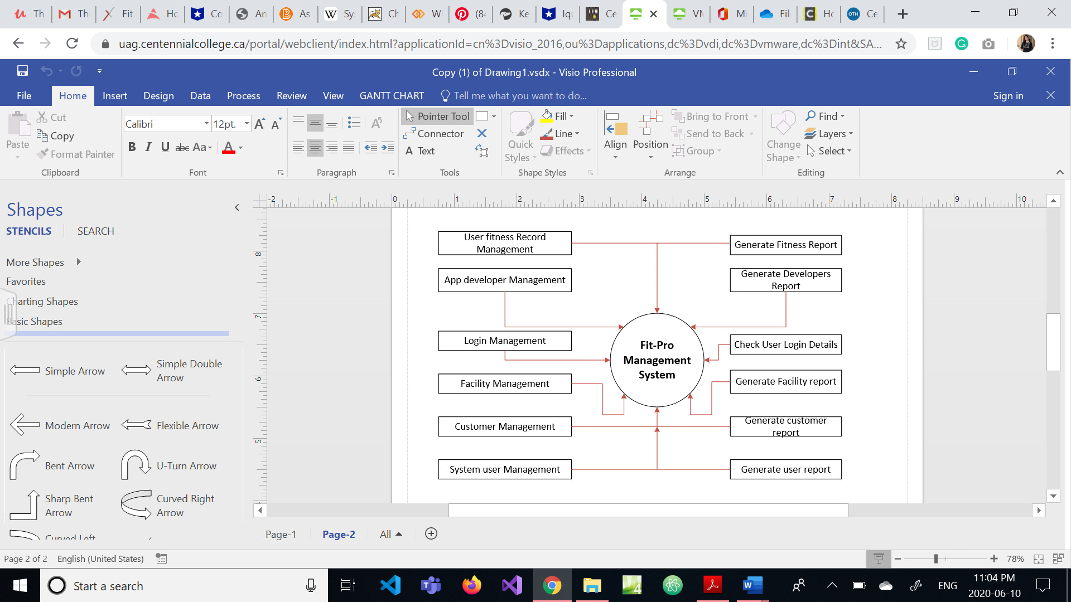

### 3.2 Hardware Interfaces:

Pulse sensor - This sensor monitors the pulse with the change in the blood vessels when the heart pumps the blood.

Skin response sensor - The sensor checks the body temperature continuously to track the stress level caused during the workout.

Accelerometer – Electromechanical device that measures acceleration forces such as during physical activity like jumping, running, and cycling which helps to keep track of calories burnt.

GPS Watch - A GPS tracks the location of the user. Built-in smartwatch or smartphone.

Ambient Light sensor - The sensor detects the amount of light in the surrounding area and adjust the brightness of screen display so that eye strain can be avoided.

### 3.3 Software Interfaces:

Calendar - Software interface will communicate with the calendar for the routine planning of the diet and workout. This helps to keep the track of physical activity.

Application Programming Interface - API helps to communicate with the backend server so that they can use the commands already built.

Notifications - Notification shows the daily feed and reminders set for the diet, workout, or Yoga.

My SQL database - It capture the information entered by the user and stores it. SQL is easy access the database also it saves the posts and reviews that the user posts and keeping track of user data becomes easy.

App Store or Google Play - App stores are the gateway to the application. These are needed to download the application to the device being used like IOS or Android.

Operating System - Application can run on the device if it is able to communicate with the OS of the device.

Payment Gateway - Payment Gateway is a web-based portal that is used for the payment exchange. It is a business application specialist organization that approves the payments through the cards and other authorized channels and puts it into the secure channel while its in process and sends it to the issuing bank or the authority for approval for the online business runners.

### Stakeholder Register

|  |  |  |  |  |  |  |
| --- | --- | --- | --- | --- | --- | --- |
| **STAKEHOLDER REGISTER** | | | | | | |
| **NAME** | TYPE OF STAKEHOLDER | EMAIL | INTERNAL/EXTERNAL | INTEREST | OPERATIONAL/EXECUTIVE | POWER |
| **JOSEPH** | OWNER | Joseph12@yahoo.com | INTERNAL | HIGH | EXECUTIVE | HIGH |
| **TAYLOR** | INVESTOR | Taylor67@gmail.com | EXTERNAL | HIGH | EXECUTIVE | HIGH |
| **RILEY** | FINANCIAL MANAGER | riley@yahoo.com | INTERNAL | MEDIUM | EXECUTIVE | MEDIUM |
| **CHARLIE** | ADVERTISING MANAGER | charlie00@hotmail.com | INTERNAL | MEDIUM | OPERATIONAL | MEDIUM |
| **SOPHIE** | PROGRAMMAR | sophie56@gmail.com | INTERNAL | MEDIUM | OPERATIONAL | MEDIUM |
| **ESMA** | USER | esma@hotmail.com | EXTERNAL | HIGH | OPERATIONAL | LOW |
| **John** | SECURITY | John09@gmail.com | INTERNAL | HIGH | OPERATIONAL | HIGH |
| **Adam** | FITNESS COACH | A.fit@hotmail.ca | INTERNAL | HIGH | OPERATIONAL | MEDIUM |

### Use Case Table

|  |  |  |  |
| --- | --- | --- | --- |
| **Use Cases** | | | |
| **Use case Name** | **Requirement ID** | **Actor(s)** | **Description** |
| User profile | FP02 | Client | Create items such as personal recipes and meal/foods. Create items such as personal workouts. |
| Calculate the daily nutrition goals | FP03 | Client | Client enters their current height, weight, age, and goal weight. The software will automatically calculate the BMI and present the user with a daily calorie intake and macro-nutrient goal. This will be saved to the personal profile. |
| Payments | FP08 | Client | Pay for premium membership for premium content. |
| Advertising | AM01 | Advertising Manager | The actor will be managing all the promotional things to promote the applications in the form of advertisements on different servers and computers. |
| Getting Notifications | FC01 | Fitness Coach | Upload daily and weekly workouts to the server for premium clients. |
| Reminders | FP06 | Client | Remind the client to check the progress and to do exercises that are not completed from time to time so that the client will not forget to do the exercises. (Will be sent directly from the app) |
| Sharing Progress | FP07 | Client, Family, Friends | There will be an option for the client to share their progress with their family and friends on social media. |
| Sharing App | PP04 | Client | An option in the app for the client if they like the application they can share the link with others and by sharing the link they can earn rewards. |
| Login to the application | FP01 | Client | Register on the FIT-PRO application by entering the client details like name, email ID and password. After the client enters the details, the account is created on FIT-PRO servers. |

# Section 4

### Functional Requirements List 1

|  |  |  |  |  |
| --- | --- | --- | --- | --- |
| Functional Requirements List | | | | |
| Requirement ID | Requirement Title | Short Description | Priority | Requester |
| FR01 | Summary | Give a summary daily and end of week | high | User |
| FR02 | Warning | A warning when user goes over suggested macro or calorie intake | high | User |
| FR03 | Unit converter | To convert between kg and lbs within app | medium | User |
| FR04 | Request Feature | A section for users to request new ideas or features | low | User |
| FR05 | Profile | Users should be allowed to create and manage profiles | low | User |
| FR06 | Authorization Levels | Allow different levels of authorization | high | Programmer  Security |
| FR07 | Print | Export printable files of data | medium | Programmer  User |
| FR08 | Nutrition Calculator | Calculates macros and calories | high | Programmer |
| FR09 | Coaching | Creates 30-min workouts daily | high | Fitness Coach |
| FR10 | Certification | All certificates to run app (online, governmental, business) | high | Programmer  Owner  Fitness Coach |

### Use Case Formal Description

|  |  |  |
| --- | --- | --- |
| Use case name | Get the premium membership |  |
| Primary actor | Client |  |
| Goal in context | To track physical activities and to stay fit |  |
| Preconditions | Client requires internet connection to access the app. |  |
| Trigger | Client decides they want to upgrade to access premium features |  |
| Scenario details | Client | System |
|  | The client opens the app and make a user profile.  Client requests nutrition information and progress report.  Client will select the videos and select the offers for the membership. | System will generate and sync the data.  It calculates the nutrition level.  System shows the diet plans according to the nutrition level.  System will show the payment methods. |
| Exceptions | A client can use another method for payment if it is not received by the application. |  |
| Priority | Shows the diet plans and videos according to the nutrition level |  |
| When available | When client opens the app |  |
| Frequency of use | Mostly |  |
| Channel to actor | Through app |  |

### Swim Lane Diagram

**CLIENT                                      SYSTEM**

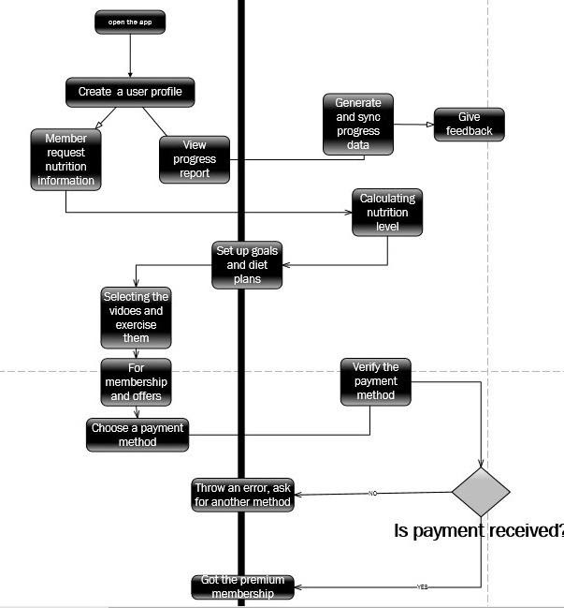

### Use Case Diagram

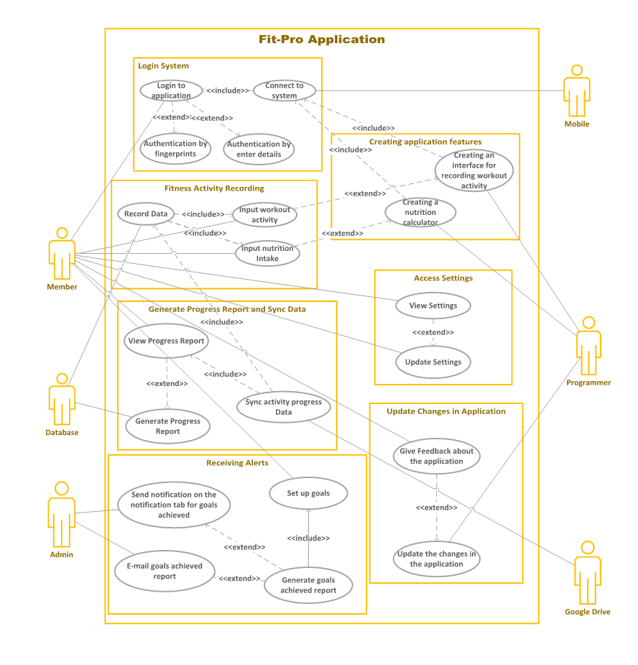

# Section 5

### Non-Functional Requirement List 1

|  |  |  |  |  |
| --- | --- | --- | --- | --- |
| Non-Functional Requirements List | | | | |
| Requirement  id | Requirement  title | Short Description | Priority | Requester |
| NFR01 | Maintainability | As of changing technology there will be need to update the app time to time | high | Programmer |
| NFR02 | Availability | The application must have to be available all the time so that whenever the user is free, he will use it | high | User |
| NFR03 | Capacity | The app should be able to handle a data of a person | medium | Programmer |
| NFR04 | Performance | The response time must be fast | medium | Programmer |
| NFR05 | Security | There must be a personal account for everyone | low | Security officer |
| NFR06 | Data integrity | There is a need to update the data in the app | medium | Programmer |

# Appendix A

(To be determined)

# Appendix B

(To be determined)

# Appendix C

## Stakeholder Register

|  |  |  |  |  |  |  |
| --- | --- | --- | --- | --- | --- | --- |
| **STAKEHOLDER REGISTER** | | | | | | |
| **NAME** | TYPE OF STAKEHOLDER | EMAIL | INTERNAL/EXTERNAL | INTEREST | OPERATIONAL/EXECUTIVE | POWER |
| **JOSEPH** | OWNER | Joseph12@yahoo.com | INTERNAL | HIGH | EXECUTIVE | HIGH |
| **TAYLOR** | INVESTOR | Taylor67@gmail.com | EXTERNAL | HIGH | EXECUTIVE | HIGH |
| **RILEY** | FINANCIAL MANAGER | riley@yahoo.com | INTERNAL | MEDIUM | EXECUTIVE | MEDIUM |
| **CHARLIE** | ADVERTISING MANAGER | charlie00@hotmail.com | INTERNAL | MEDIUM | OPERATIONAL | MEDIUM |
| **SOPHIE** | PROGRAMMAR | sophie56@gmail.com | INTERNAL | MEDIUM | OPERATIONAL | MEDIUM |
| **ESMA** | USER | esma@hotmail.com | EXTERNAL | HIGH | OPERATIONAL | LOW |
| **John** | SECURITY | John09@gmail.com | INTERNAL | HIGH | OPERATIONAL | HIGH |
| **Adam** | FITNESS COACH | A.fit@hotmail.ca | INTERNAL | HIGH | OPERATIONAL | MEDIUM |

# Appendix D

## Interview Questions

|  |  |  |
| --- | --- | --- |
| **Interview Questions** | | |
| **Questions** | **Stakeholder Positions** | **Answers** |
| What is the Budget of the project? | Chief Financial Manager | 2,000,000 CAD |
| Who will be targeted users? | Marketing/Advertising Manager | Teenagers, adults and middle aged. |
| What problem will the Fit-Pro application solve for the user? | Customers/Users | It will improve their lifestyle by keeping the track of their physical activity and eating habits. |
| What type of Database will be used in the application? | Database Administrator | SQL |
| What will be the challenges while building this application? | Project Manager | The technology being used is as per the recent technology standards or not and do team have application developers. |
| What will the application look like or design preference? | Front End Developer | Has to be easy to navigate and fun to use |
| What language will be used to build this application? | Developer/Programmer | PHP |
| How will the application be monetized? | Advertiser | Will run the advertisements on the application. |

# Appendix E

## Class Diagrams

### Domain Class Diagram

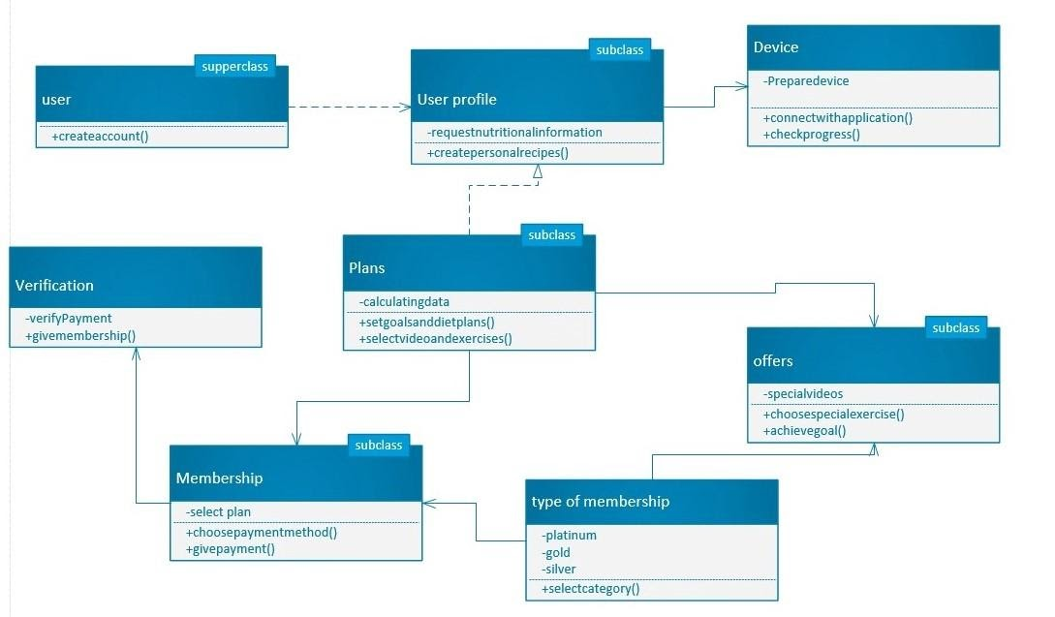

### CRC Cards

|  |  |
| --- | --- |
| **Add Item Screen** | |
| **Responsibilities** | **Collaborator** |
| Collect recipe info | Client Handler |
| Collect food/meal info |
| Collect exercise info |

|  |  |
| --- | --- |
| **Calculate Screen** | |
| **Responsibilities** | **Collaborator** |
| Collect client personal info | Client Handler |
| Collect goals info |
|  |

|  |  |
| --- | --- |
| **Client Handler** | |
| **Responsibilities** | **Collaborator** |
| Create client | Client |
|  |
|  |

|  |  |
| --- | --- |
| **Client** | |
| **Responsibilities** | **Collaborator** |
| Create personal info | Personal Information |
| Create goals info | Goal Information |
| Create payment info | Payment Information |
| Get client details |  |
| Update client details |  |

|  |  |
| --- | --- |
| **Personal Information** | |
| **Responsibilities** | **Collaborator** |
| Get current height, weight, age |  |
| Update current height, weight, age |  |
|  |  |

|  |  |
| --- | --- |
| **Goal Information** | |
| **Responsibilities** | **Collaborator** |
| Get goal weight |  |
| Update goal weight |  |
|  |  |

|  |  |
| --- | --- |
| **Add Item Information** | |
| **Responsibilities** | **Collaborator** |
| Get recipe, meal, exercise details |  |
| Update recipe, meal, exercise details |  |
|  |  |

## State Diagram

### Login Process

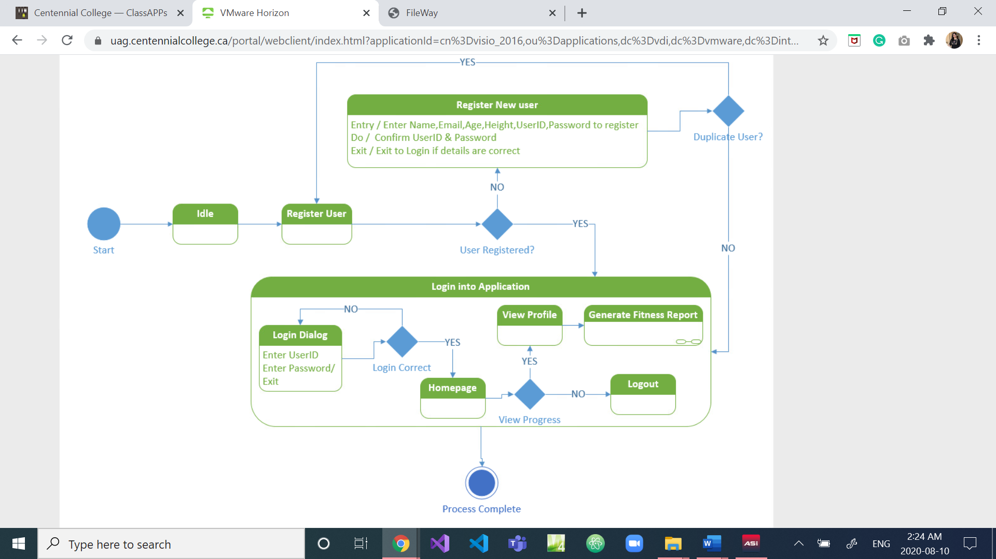

### Record Fitness Activity

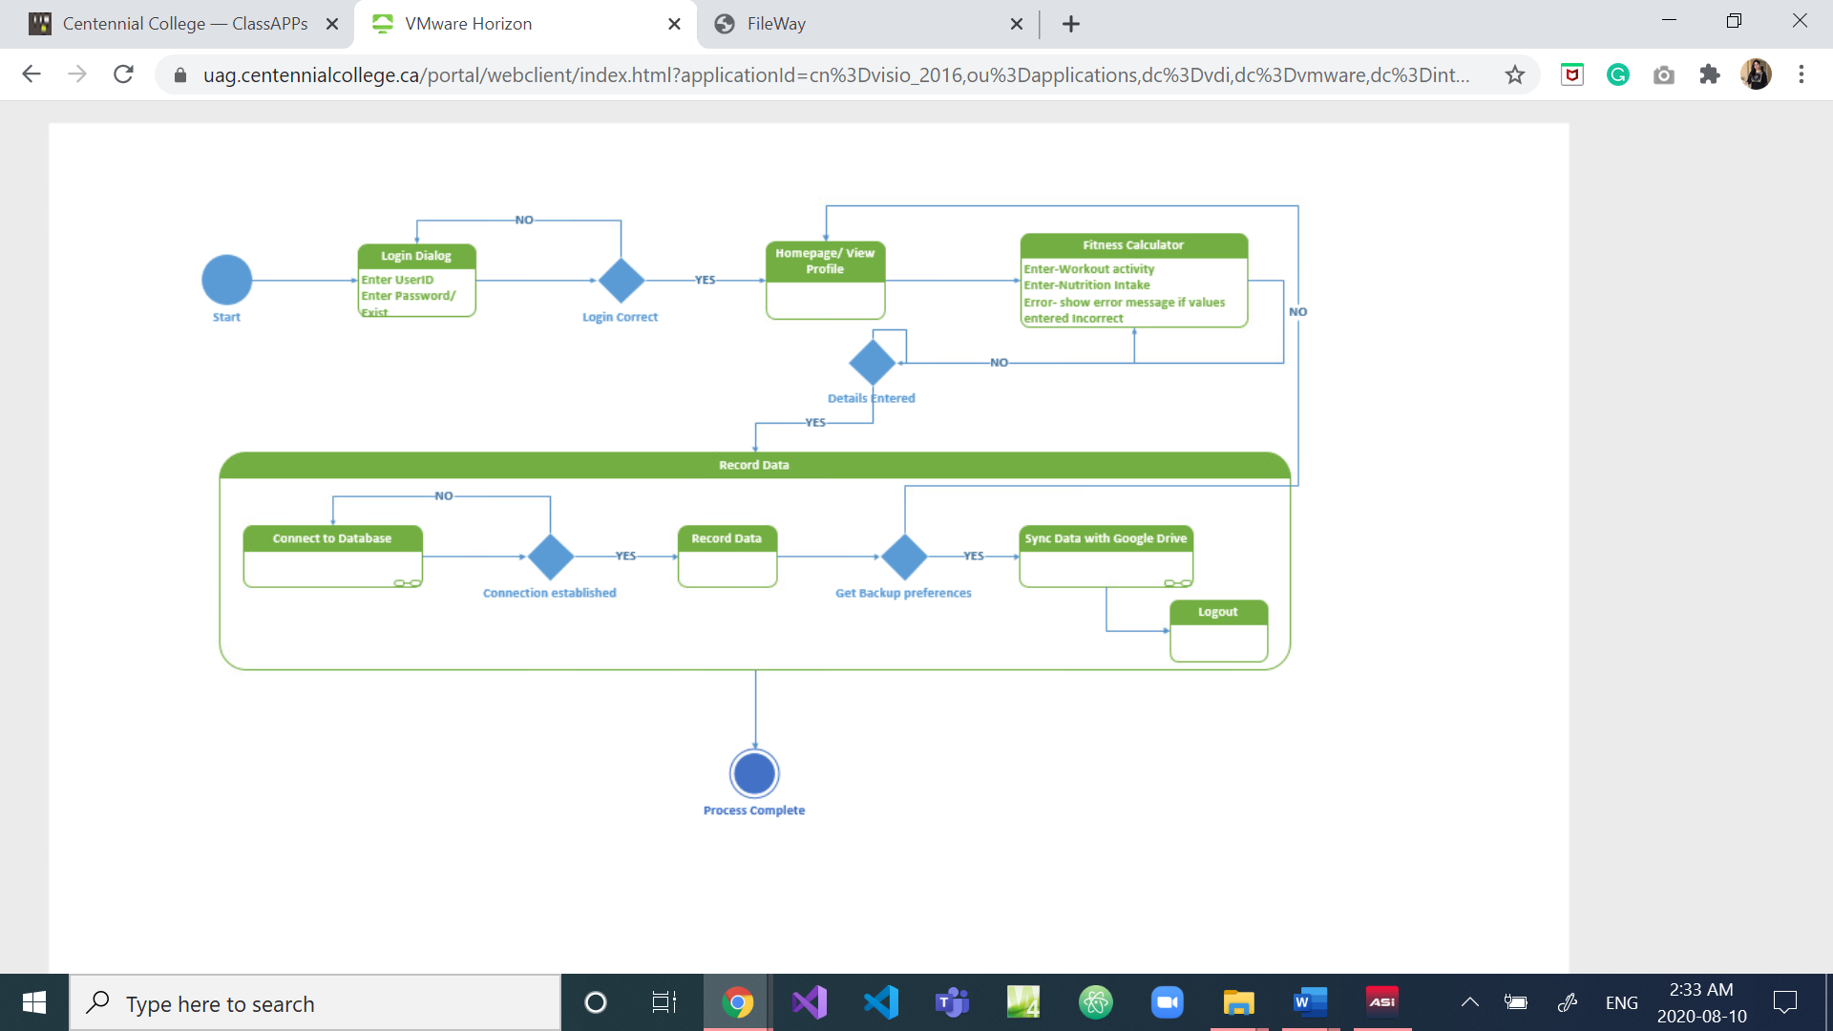

## Sequence Diagram

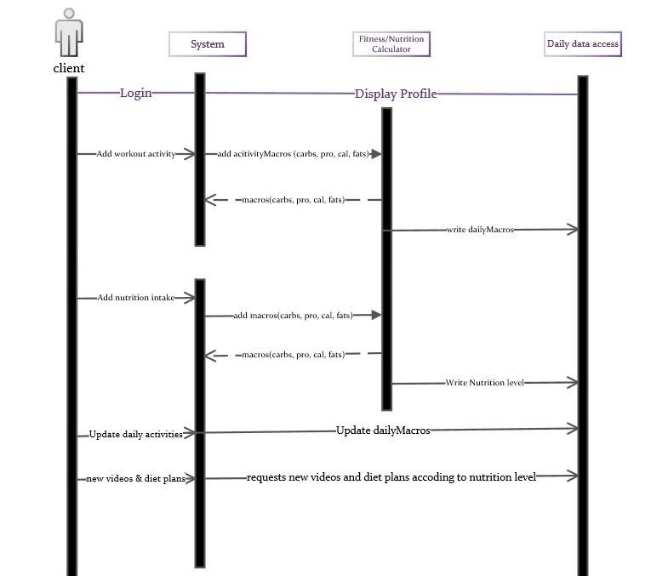

# References

1. <https://www.bing.com/images/search?view=detailV2&ccid=lJ2hvhIm&id=15B91A53214A8E8B092395E761C6FB355C92E4F2&thid=OIP.lJ2hvhImywkDaoVVfnPi3AHaEl&mediaurl=https%3A%2F%2Fandreaskambanis.com%2Fwp-content%2Fuploads%2F2015%2F05%2Fcalories-macros-chart.jpg&exph=495&expw=800&q=calories+and+macros+on+a+app&simid=608020145959995594&ck=9DF1B59BE35DE535D4E3A4CC8738B438&selectedindex=72&ajaxhist=0&vt=0&sim=11>
2. <https://www.peerbits.com/blog/technologies-used-build-fitness-tracking-app.html>
3. <https://www.brainvire.com/top-5-benefits-of-health-and-fitness-mobile-apps/>
4. <https://reqtest.com/requirements-blog/functional-vs-non-functional-requirements/>
5. <https://www.fiercewireless.com/developer/maintaining-app-critical-to-its-overall-success>
6. <https://www.google.com/search?q=data+integirity&rlz=1CAUFPX_enCA895CA895&oq=data+integirity&aqs=chrome..69i57j0l7.4842j0j8&sourceid=chrome&ie=UTF-8>
7. <https://krazytech.com/projects/sample-software-requirements-specificationsrs-report-airline-database>